# CS 255 System Design Document Template

This template lays out all the different sections that you need to complete for Project Two. Each section has guidance to prompt your thinking. You will need to continually reference the interview transcript as you work to make sure that you are addressing your client’s needs. There is no required length for the final document. Instead the goal is to complete each section based on what your client’s needs are. Remove this note when you are finished, and replace all bracketed text with the relevant information.

## UML Diagrams

### UML Use Case Diagram

*[In Module Six, you were asked to complete a use case diagram based on your system design. If you would like to make any adjustments to your diagram, please do so. Please insert your use case diagram here. Check to make sure that you included appropriate components and symbols and that your design meets the client’s needs.]*

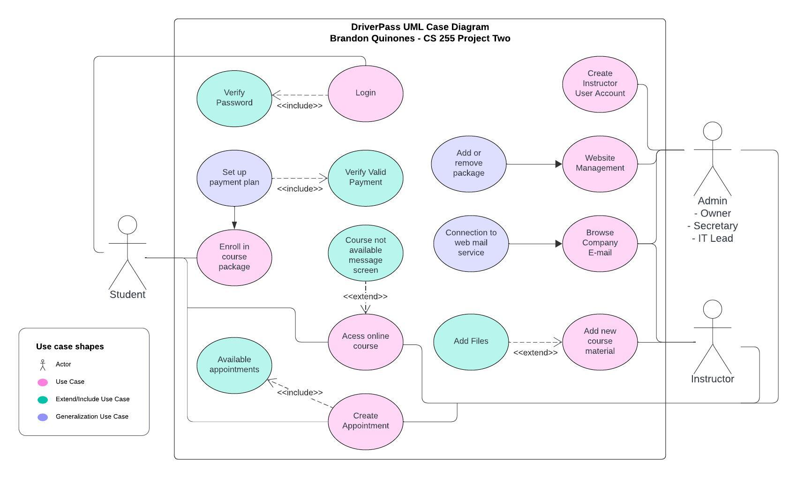

### UML Activity Diagrams

*[You were asked to choose* ***two*** *use cases and create* ***two*** *activity diagrams, one for each use case. Please insert* ***both*** *of your activity diagrams here. Check to make sure that you included appropriate components and symbols and that your design meets the client’s needs.]*

### UML Sequence Diagram

*[You were asked to create a sequence diagram based on* ***one*** *of the use cases you chose. Please insert your sequence diagram here. Check to make sure that you included appropriate components and symbols and that your design meets the client’s needs.]*

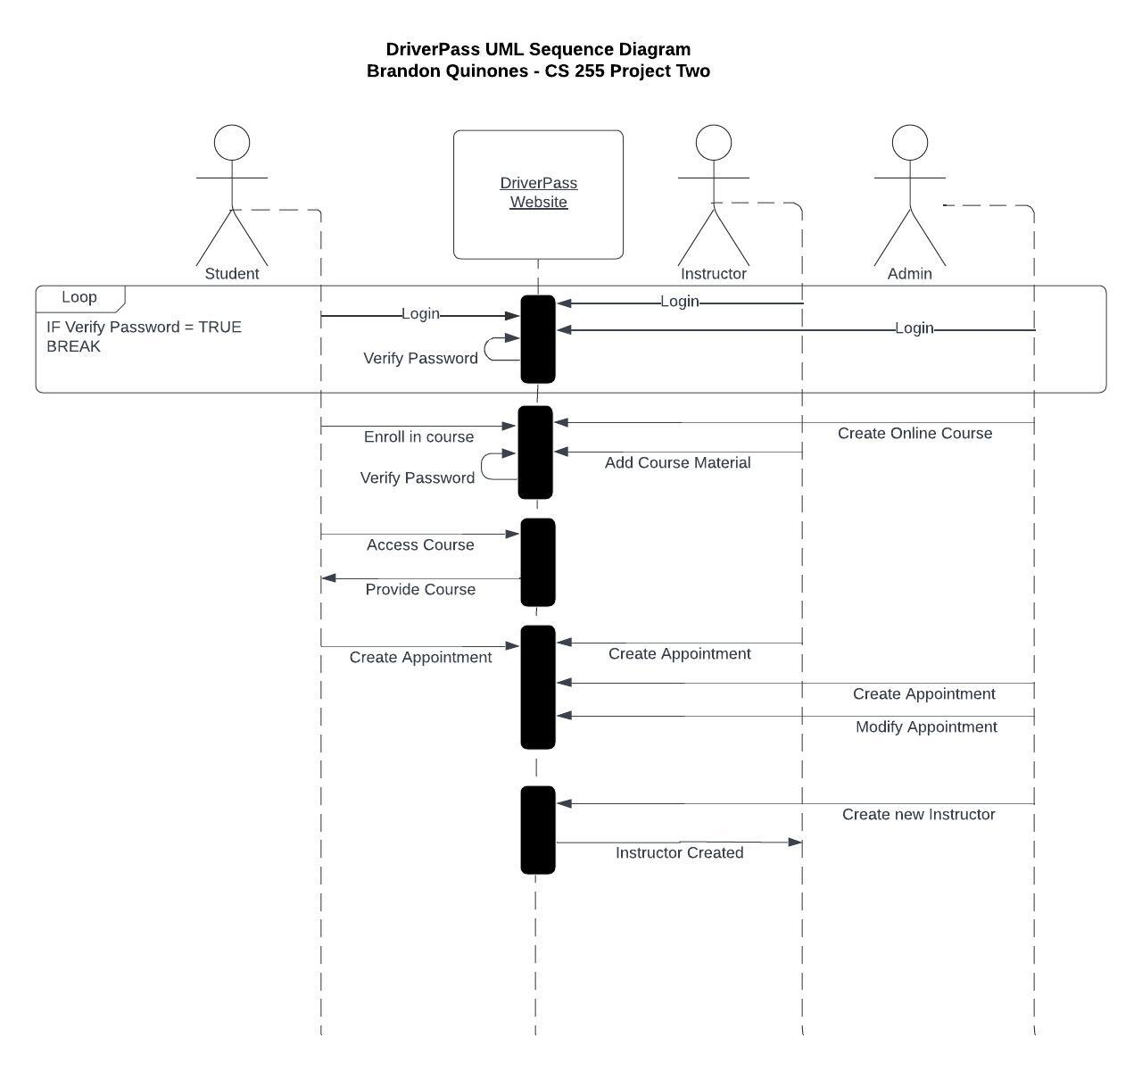

### UML Class Diagram

*[You were asked to create a class diagram based on the different classes and attributes needed for your system design. You are* ***not*** *required to include methods, but you may if you wish. Please insert your class diagram here. Check to make sure that you included appropriate components and symbols and that your design meets the client’s requirements.]*

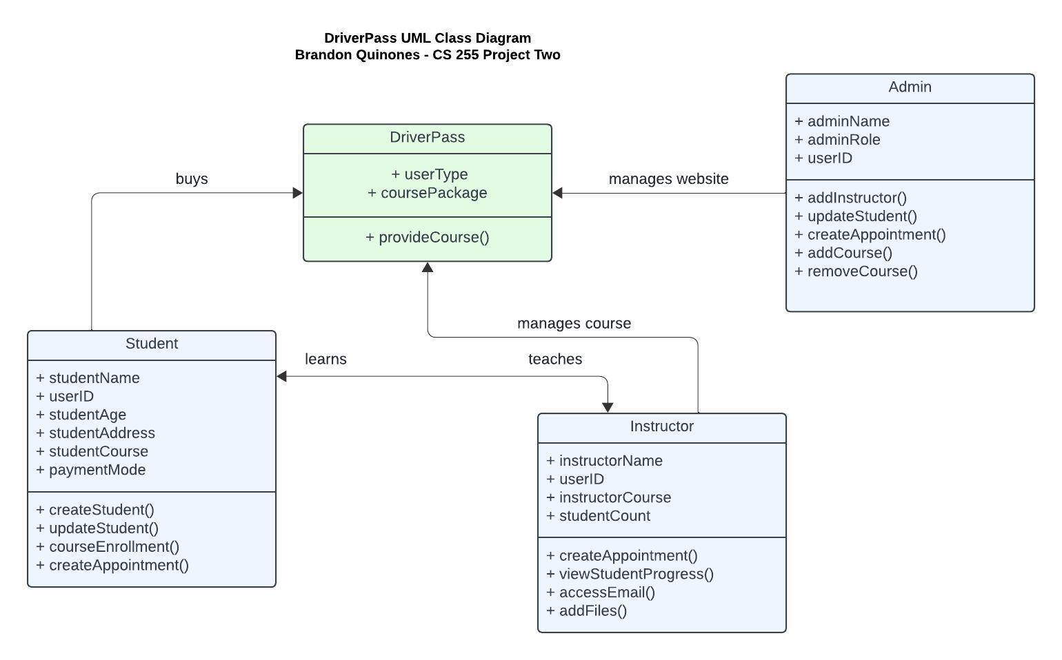

## Technical Requirements

*[Based on the diagrams you have created, describe the technical requirements of your system. These requirements should address the required hardware, software, tools, and infrastructure necessary for your system design.]*

For this application for DriverPass, very little hardware is needed. The website itself can reside in a serverless cloud environment. A serverless environment offers cloud connection meaning that I can be anywhere at anytime and connect and make changes to the application remotely. Serverless also is cheaper, and you only need to pay for what you use.

The software needed would be a good IDE, Eclipse is good, but it is also too generic of an IDE to me. I would prefer to use JetBrains IntelliJ to program this, as it offers more functionality and collaboration. A git repository would also be needed as well as the use of Springboot and Maven for REST API functionality.

Tools needed are many as a web-based app is not as simple as it seems. Jenkins would also be needed for CI/CD continuous integration and continuous delivery. Front end development would require tools such as Angular or React for application framework development and Ansible for configuration management and app deployment. For security there are many solutions, such as SonarQube for example. Having code coverage is essential to owning an application to mitigate security risks.